Secure Automated Quality Assurance (AQA) System

Security in Software Engineering – Final Report

1. Introduction
With the increasing reliance on automated testing tools in modern software development, securing Quality Assurance (QA) systems has become essential. Automated QA systems often handle sensitive information such as test data, credentials, reports, and execution logs. If compromised, these systems can become entry points for larger attacks.
This project presents the design and partial implementation of a Secure Automated Quality Assurance (AQA) System, developed according to Secure Software Development Life Cycle (Secure SDLC) principles. The project focuses on identifying security risks early, applying threat modelling, designing secure architectures, implementing security controls, and validating them through security testing.

2. System Overview
The Automated Quality Assurance (AQA) System is a backend-based platform that allows testers to execute automated test cases and view test results, while administrators manage users and system configurations. The system is accessed through secure API endpoints and uses token-based authentication to protect resources.
The main goals of the system are: - Secure authentication and authorization - Protection of test execution data - Prevention of unauthorized access - Accountability through logging and auditing

3. Phase 1 — Requirements Analysis

3.1 User Roles
- Admin: Responsible for managing users, assigning roles, and accessing all system reports.
- Tester: Executes automated tests and views assigned test results.

3.2 Functional Requirements
- The system shall allow users to log in using secure credentials.
- The system shall allow testers to execute automated test cases.
- The system shall store test execution results securely.
- The system shall allow administrators to manage users and roles.
- The system shall generate test execution reports.
These requirements define what the system is expected to do from a functional perspective.

3.3 Non-Functional Security Requirements
- Passwords shall be hashed and salted before storage.
- The system shall enforce Role-Based Access Control (RBAC).
- All user inputs shall be validated to prevent injection attacks.
- Sensitive data shall be encrypted during storage and transmission.
- Security-related events shall be logged and auditable.
These requirements ensure that the system operates securely under all conditions.

3.4 High-Value Assets
- User credentials
- JWT authentication tokens
- Test execution results
- Test reports and logs
Protecting these assets is critical to maintaining system security.

3.5 Context Diagram
Users interact with the AQA System via secure API endpoints. The system processes requests, enforces authentication and authorization, and stores data in a backend database. All interactions are logged for auditing purposes.

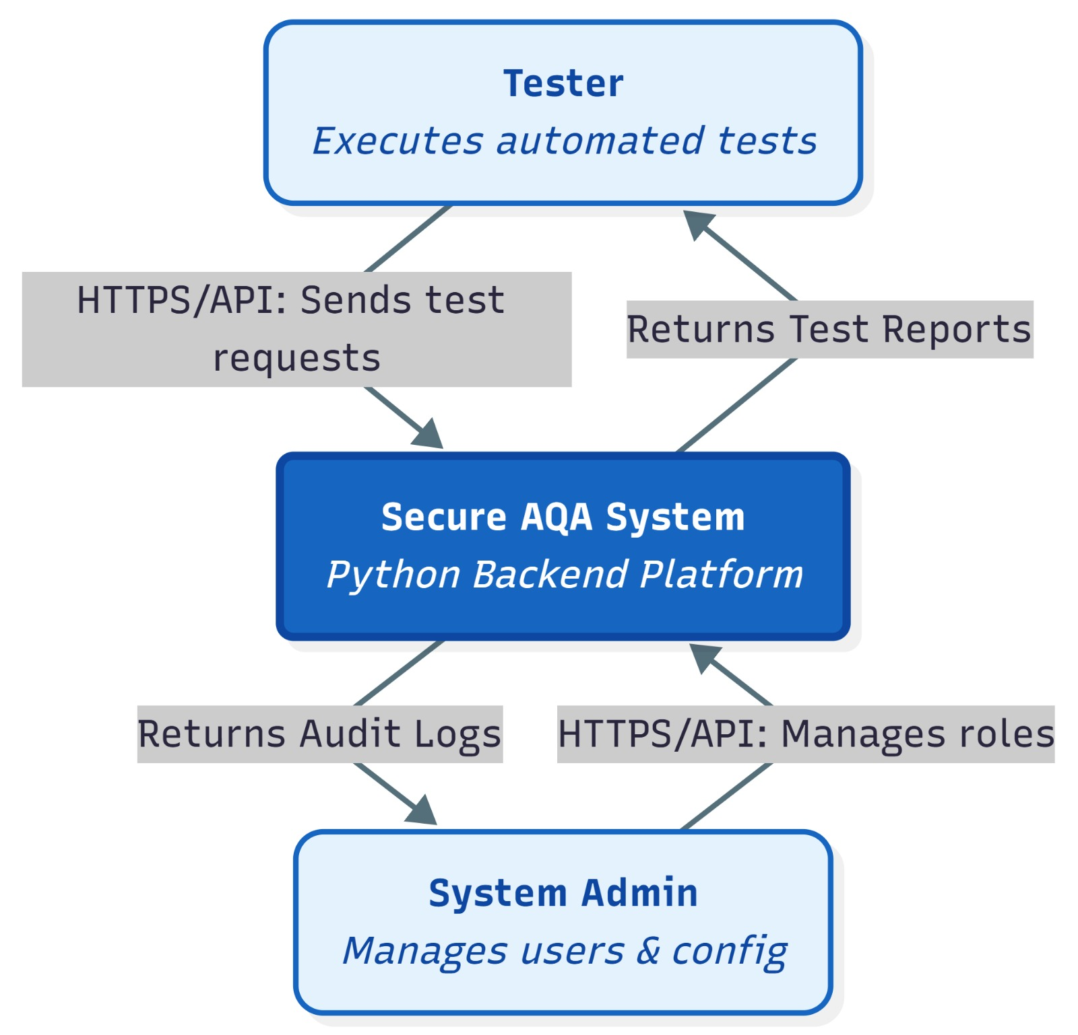

4. Phase 2 — Threat Modelling

4.1 Methodology
The STRIDE threat modelling methodology was applied to systematically identify potential threats across the system. STRIDE covers: - Spoofing - Tampering - Repudiation - Information Disclosure - Denial of Service - Elevation of Privilege

4.2 Identified Threats and Mitigations
ID | Category | Threat Description | CIA Impact | Risk | Mitigation
T1 | Spoofing | Unauthorized login using stolen credentials | C | High | Strong authentication, account lockout
T2 | Tampering | Modification of test results | I | High | Access control, integrity checks
T3 | Repudiation | User denies executing a test | I | Medium | Audit logging
T4 | Info Disclosure | Leakage of test reports | C | High | Encryption, RBAC
T5 | DoS | Flooding test execution requests | A | Medium | Rate limiting
T6 | Elevation | Tester gains admin privileges | C/I | High | Strict RBAC enforcement
T7 | Tampering | JWT token manipulation | I | High | Token signing and validation
T8 | Info Disclosure | Sensitive data in logs | C | Medium | Log sanitization

4.3 Risk Assessment
Risks were evaluated based on likelihood and impact, and classified into Low, Medium, or High risk levels. High-risk threats were prioritized for mitigation in the secure design phase.

5. Phase 3 — Secure Design

5.1 System Architecture
The system follows a client-server architecture consisting of: - Client (Postman or frontend) - Secure API layer - Database layer
Security controls are enforced at the API layer before accessing backend resources.

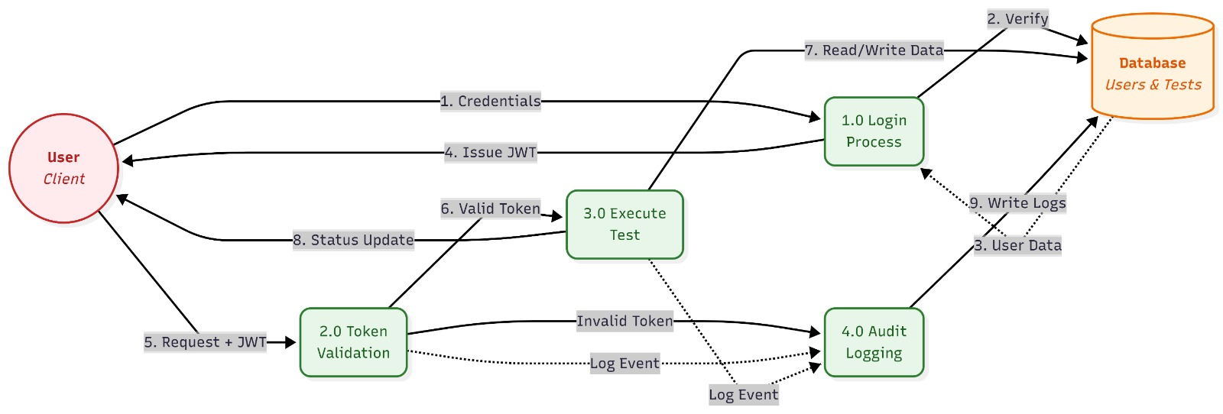

5.2 Role-Based Access Control (RBAC)
Role | Permissions
Admin | Manage users, view all reports
Tester | Execute tests, view own reports
RBAC ensures least-privilege access.

5.3 Data Flow
- User submits login credentials.
- System validates credentials and issues a JWT token.
- User accesses protected endpoints using the token.
- Test execution results are securely stored in the database.

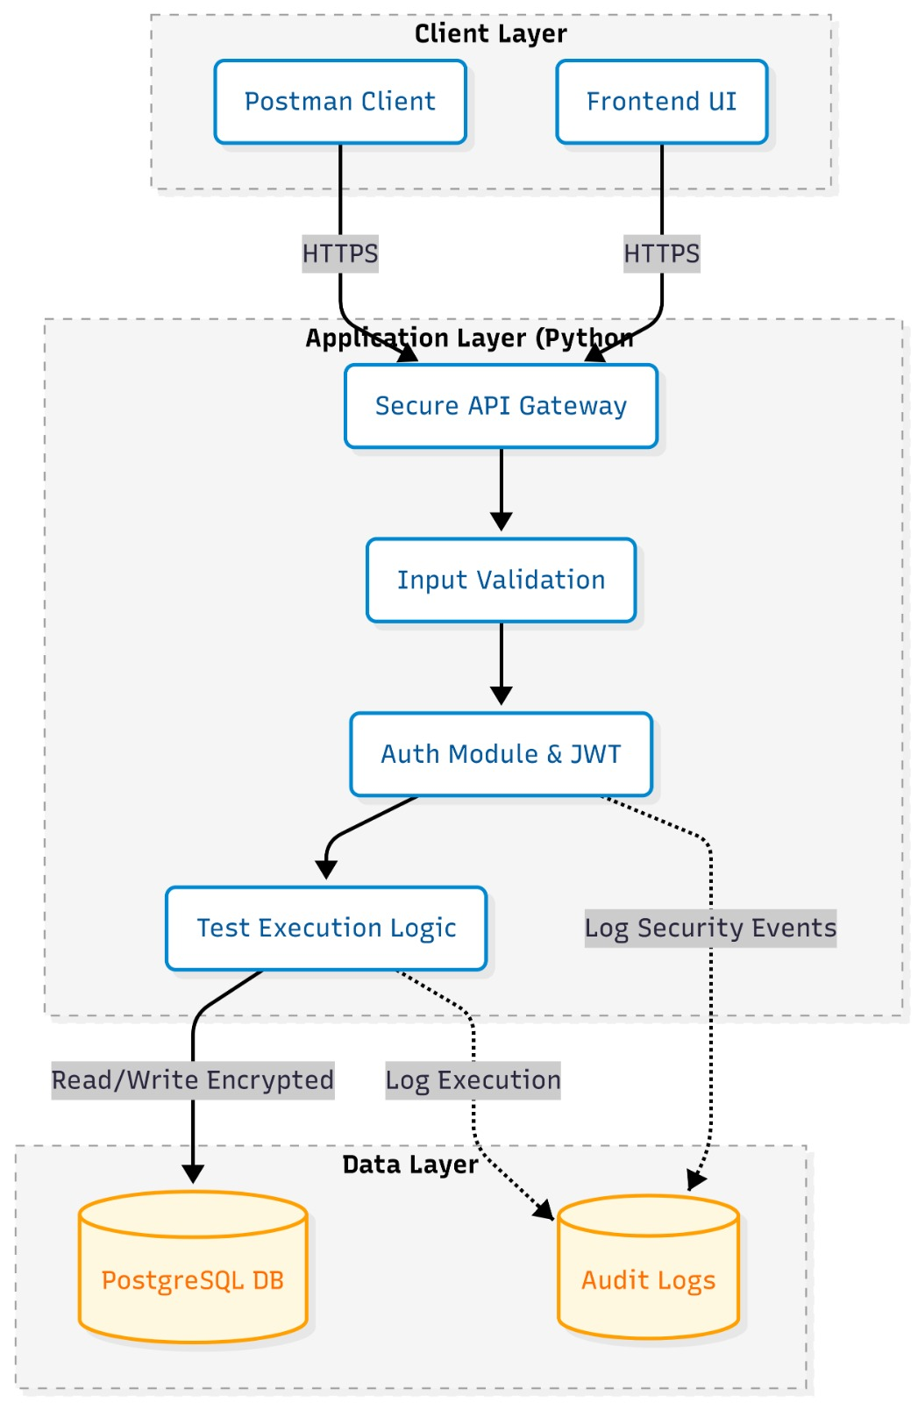

5.4 Secure Input Validation
- Validate data types and lengths
- Reject empty or malformed inputs
- Sanitize all user-provided data

5.5 Cryptographic Design
- Password hashing: bcrypt
- Authentication tokens: JWT
- Sensitive data encryption: AES

5.6 Audit Logging
The system logs: - Successful and failed login attempts - Account lockouts - Token validation failures - Privileged operations
Logs include timestamps and user identifiers.

6. Phase 4 — Implementation Overview
A Python-based prototype was developed implementing: - Secure login with password hashing - JWT-based authentication - Input validation mechanisms - Encryption utilities - Secure logging
Secure coding practices were followed, including proper error handling and avoiding hardcoded secrets.

7. Phase 5 — Security Testing
Security testing validated the effectiveness of implemented controls. Tests covered: - Authentication and authorization - Input validation - Token integrity and expiration - Misuse scenarios
All critical security requirements were successfully tested.

8. Lessons Learned
- Security must be integrated from early development stages.
- Threat modelling helps uncover hidden vulnerabilities.
- Logging is essential for accountability and incident response.
- Secure defaults significantly reduce attack surfaces.

9. Conclusion
This project demonstrates how a secure Automated Quality Assurance System can be designed and partially implemented using Secure SDLC principles. Through structured requirements, threat modelling, secure design, implementation, and testing, the system achieves strong security guarantees while remaining practical and extensible.
Future improvements may include advanced monitoring, database hardening, and deployment in a secure cloud environment.

Submitted by:
Belal Elshazly 221007975
Omar Waleed 221017650

